Dataset: <https://www.kaggle.com/datasets/shivamb/netflix-shows>

Question 1:

Which countries produce the most content?

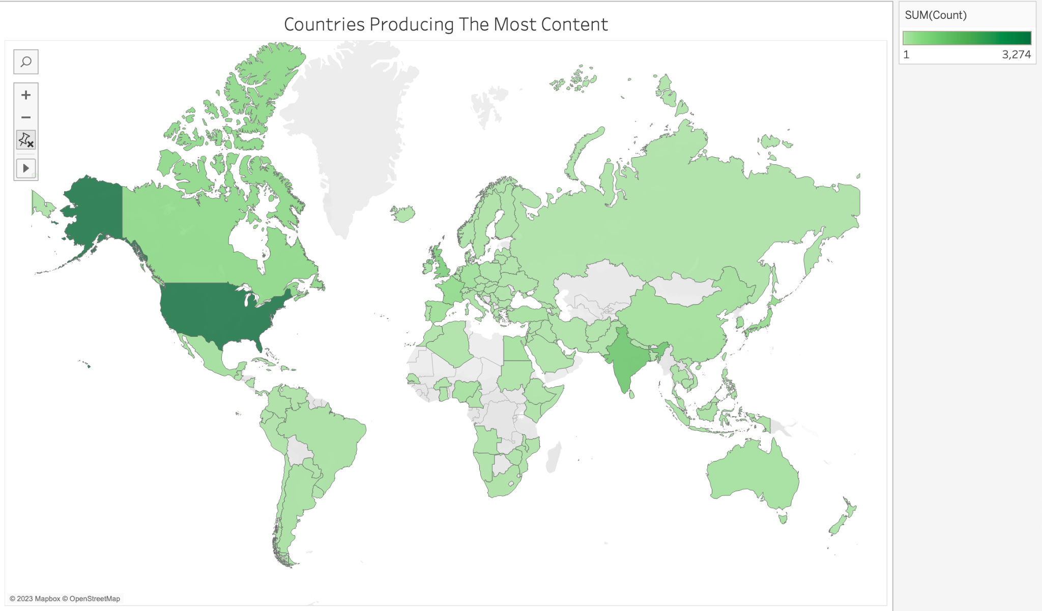

Question 2:

Top 10 Genre’s on Netflix?

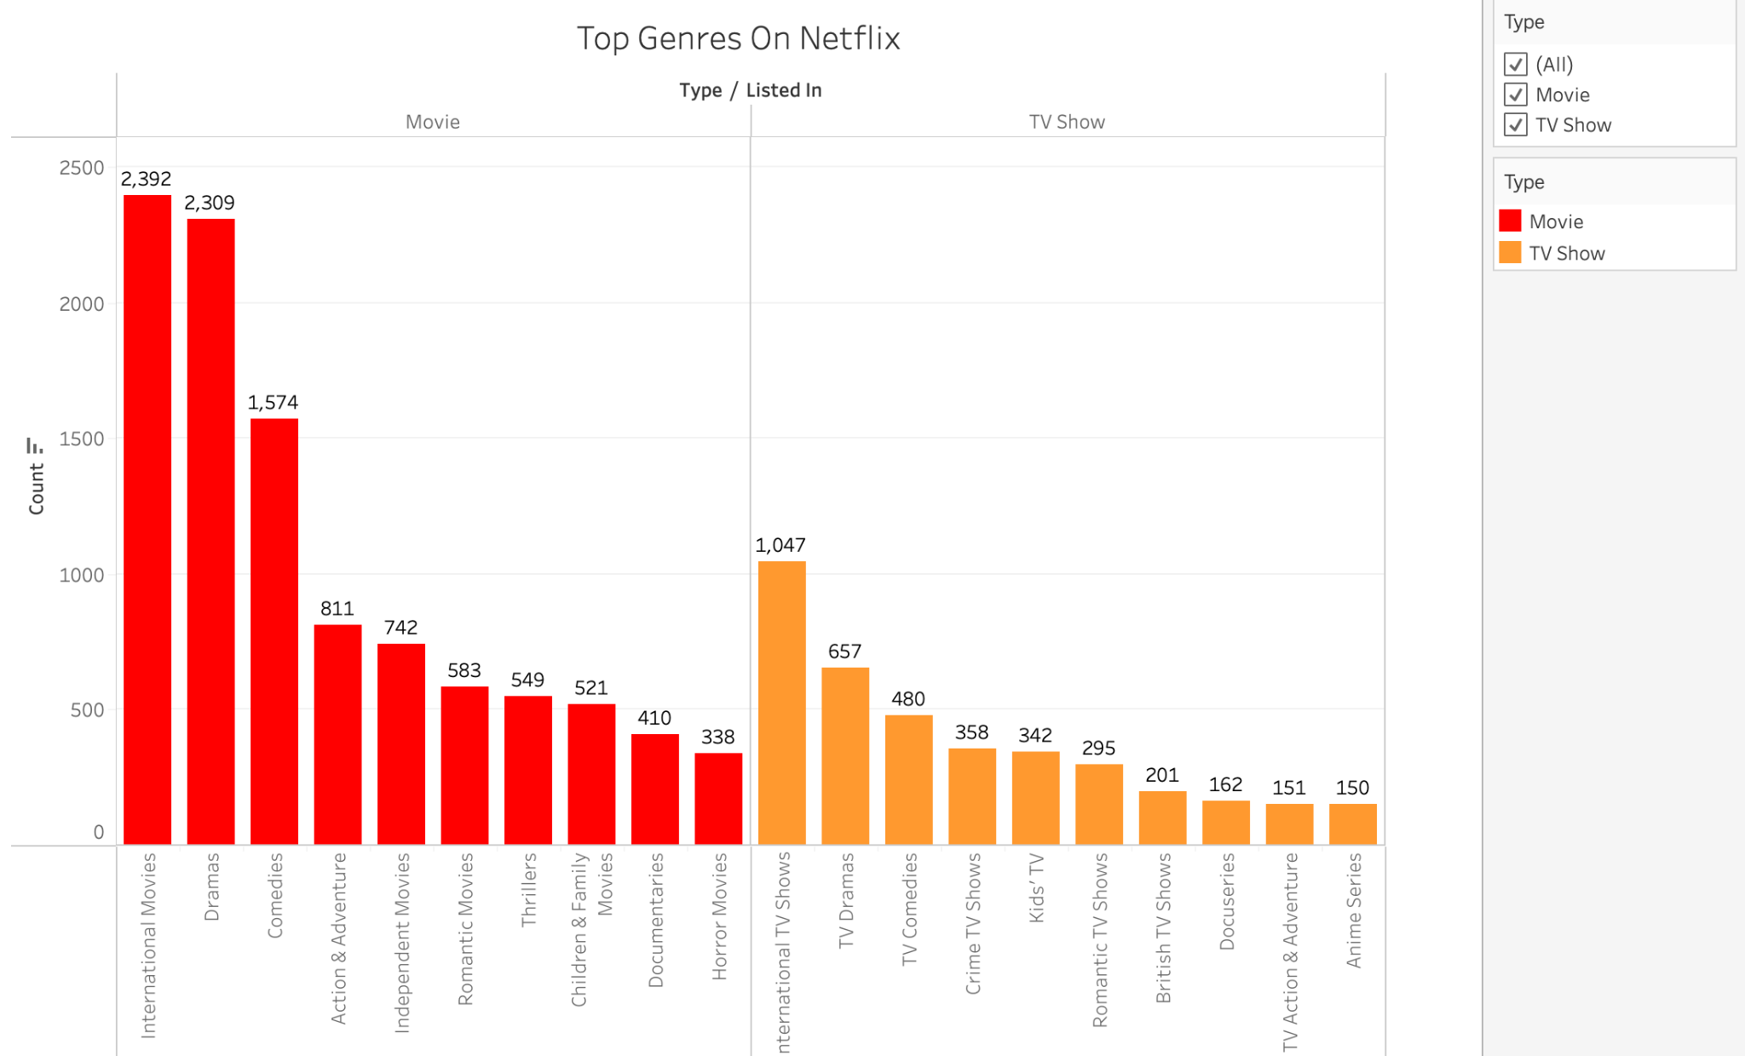

**Describing your dataset and what data it contains:**

Where was it obtained, what are the dimensions of it (rows and columns), what are the various

columns, data types, etc. Describe it in sufficient detail so that an uninformed reader would

understand the dataset.

**The 2 questions the team generated and why they are interesting and important:**

What are the questions, and why each question is important. Importance can be evaluated and

conveyed in a variety of ways including, social, economic, cultural and other factors. Also

indicate how they are tied to the data set or sets being used.

**The manipulations applied to the data set as part of the analysis:**

Were there any manipulations or calculations that needed to be performed on the data, what were

they, describe the purpose and how they were accomplished.

**Analysis and Results:**

Analyze and visualize the results of your analysis and describe the implications of your analysis.

Please provide any citations if required as well as supporting visualizations and analysis

generated from Tableau.